The Institute for a Sustainable Environment presents
The 2nd Annual ISE Clarkson Keynote Lecture

A Thin Line between Love and Hate:
Polarization & Energy in Canada and the U.S.
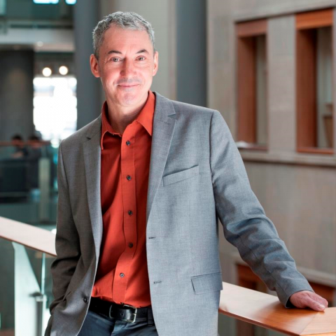

By: Dr. Stephen Bird
Associate Professor of Political Science
Director of the Adirondack Semester

Event details:
Wednesday, February 5, 2020
Lecture 4:00-5:00 pm, Snell 213
followed by a reception

___________________________________________

Energy and environmental issues are one of the lightning rods of polarized opinion in North America. The talk will focus on the how and why energy issues are polarized, and demonstrate that polarized opinion is a mix: fragmented (split with moderate views), polarized (split and concentrated at extremes), and areas of agreement.

Biography:
Dr. Stephen Bird is an Associate Professor of Political Science and Director of the Adirondack Semester at Clarkson University and a Research Faculty Affiliate with the Positive Energy Project at the University of Ottawa. His current and past research focuses on split incentives & smart housing, energy conflict, microgrid governance, factors in energy acceptance (fracking, solar, wind), green data centers, energy poverty, and environmental activism.

